

Project：Genomic Sequence Analysis System

Course：Data Structure Curriculum Design

Student Name: Jiayi WANG
Yaxuan WANG
Jiayue ZHU
Nike ZHANG

Student Number： 2024311061
2024311064
2024311065
2024311082
Faculty Adviser： Lilia SFAXI Wei WEI
Abstract
This project develops a Genomic Sequence Analysis System using fundamental data structures and algorithms for bioinformatics applications. DNA sequences are represented as doubly linked lists to support efficient mutation operations, while stacks, binary search trees (BSTs), and graphs are used for mutation history management, sequence indexing, and phylogenetic analysis. The system also implements edit distance for sequence comparison, mutation hotspot detection, dataset generation, and species classification. The project demonstrates how appropriate data structures improve the efficiency and organization of genomic sequence storage, analysis, and evolutionary relationship modeling.

Catalogue
I Description Of Project
II Requirement Analysis of Project
III Design of Project
IV Implementation of Project
V Running and Debugging of Project
VI Summary
6.1 Daily Work Schedule
6.2 Division of Labor within the Group
6.3 Tips
6.4 Difficulties and Solution of Problems

I Description Of Project

A bioinformatics research team needs tools to store, analyse, and compare genomic sequences. DNA sequences are naturally modelled as linked lists of nucleotides (enabling efficient insertions and deletions that represent mutations). A stack is used for sequence alignment via dynamic programming traceback. A BST indexes sequences by similarity for fast lookup. A graph models evolutionary relationships between species.
This project introduces students to a genuinely important application domain for data structures — one where the choice of structure directly affects the ability to answer biological questions.

II Requirement Analysis of Project
This project is developed to address the growing need for efficient computational tools in bioinformatics, specifically for analyzing genomic data. As biological research advances, scientists generate massive amounts of DNA sequence data that must be stored, compared, and visualized to understand evolutionary relationships and genetic mutations. However, a significant challenge currently exists in how this data is managed; standard text-based data structures often struggle to handle the dynamic nature of genetic mutations, such as insertions and deletions, leading to slow processing speeds and inefficient memory usage when analyzing large datasets. This project provides significant value by implementing specialized data structures—like doubly linked lists for flexible sequence modification, stacks for tracking mutation history, and graphs for modeling evolutionary trees—that are specifically chosen to solve these biological problems. By creating a system that accurately models these natural processes, the project not only optimizes the performance of sequence alignment and similarity searches but also serves as a powerful educational tool. It demonstrates to students how the fundamental choice of data structure directly impacts the ability to answer complex scientific questions, bridging the gap between abstract computer science concepts and real-world biological discovery.

III Design of Project
In order to extracts the simplest tree that explains all relationships with minimum total evolutionary distance, need to use MST to implemented this aim. I choose Kruskal's algorithm to get the MST. I use 3 main functions, I choose sort( ). This function helps me to traverse every distance and sort distance from minimum to maximum.This is the basic part of Kruskal's algorithm. I create 2 function called find( ) and union( ), this 2 function can help me prvent the circle occured in Kruskal's algorithm.Also, the method that we use need to have an eveluation, to see the porfomance of each method. So, benchmarking analysis are needed. And in this project, the result is presented through visual images chart. Final, this whole project are present as a user interface.

IV Implementation of Project

Part 1 Task 1: Data Modelling

The project follows an object-oriented design. All data model classes are placed in the src/models directory to improve code organization and maintainability.
The enums.py file defines the enumeration types Base, SequenceType, and MutationType, ensuring that only valid nucleotide bases, sequence types, and mutation types can be used throughout the system.
The nucleotide.py file implements the Nucleotide class, which stores the nucleotide base, its position, and links to the previous and next nodes, forming the basis of the doubly linked list.
The mutation.py file implements the Mutation class, recording the mutation type, mutation position, original base, and new base. This information is used for mutation management and supports undo operations in Task 3.
The sequence.py file defines the Sequence class, which stores sequence information, including the sequence ID, species name, sequence type, and the linked list representing the DNA sequence.

Part 1 Task 2: Sequence as Doubly Linked List

The DNA sequence is implemented as a doubly linked list using Nucleotide nodes. Each node maintains references to both the previous and next node, allowing efficient insertion and deletion without shifting the remaining elements.
The Sequence class provides methods for inserting, deleting, and substituting nucleotides, generating the complete sequence string, calculating the sequence length, searching for subsequences, and generating the reverse complement sequence. The reverse complement is created by reversing the linked list order and replacing each nucleotide with its complementary base (A↔T and G↔C).
Compared with Python strings, the linked list structure is more suitable for modelling DNA mutations because insertions and deletions only require updating node links rather than rebuilding the entire sequence.
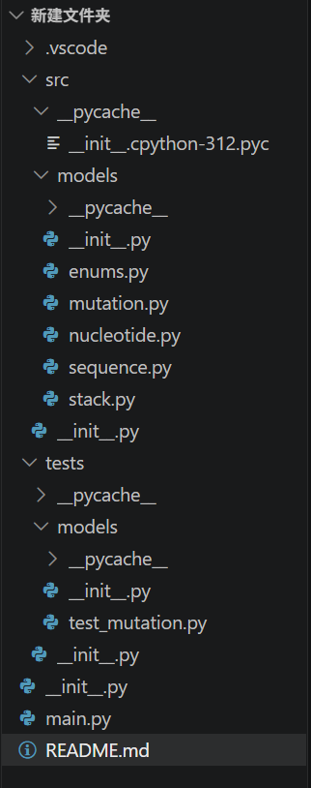

Part 1 Task 3: Mutation History Using a Stack

A stack is implemented in stack.py to record every mutation applied to a DNA sequence. The Last-In-First-Out (LIFO) property of the stack makes it suitable for undo operations.
Whenever a mutation is performed, a Mutation object is created and pushed onto the stack through the apply_mutation() method. The undo_last_mutation() method pops the most recent mutation and restores the sequence to its previous state. The mutation_history() method returns all recorded mutations for review.
Unit tests are implemented in tests/models/test_mutation.py to verify that mutation operations and undo functionality work correctly. The program entry point, main.py, demonstrates the implementation of Tasks 1–3 by creating sequences, performing mutation operations, and displaying the mutation history.

Part 1 Task 4: Sequence Library: BST

The Sequence Library is implemented using a Binary Search Tree (BST). Each node in the tree stores one DNA sequence object, and the tree is indexed by sequence_id. This allows the program to organise sequences efficiently and perform common operations.
The BST supports the following functions:
1.Add a new sequence into the tree according to its sequence ID.
2.Remove a sequence while keeping the BST structure valid.
3.Find a sequence quickly using its unique sequence ID.
4.Traverse the tree and collect all sequences that belong to the specified species.
5.Visit all nodes in ascending order of sequence ID, which produces a sorted list of sequences.
6.Using a BST makes searching, inserting and deleting efficient in most cases. Although the tree is indexed by sequence ID, the species search is completed by traversing all nodes because species is not the sorting key.
A more biologically useful alternative key would be species name or sequence similarity score instead of sequence ID. If the BST were organised by species, all sequences from the same species could be found more efficiently. If it were organised by similarity score, researchers could more easily locate sequences with similar genetic characteristics, making sequence comparison and evolutionary analysis more convenient.

Part 1 Task 5: Phylogenetic Graph

The evolutionary relationships between species are represented using an undirected weighted graph. In this graph, each node represents a species, while each edge represents the evolutionary relationship between two species. The edge weight stores the estimated evolutionary distance calculated from sequence similarity. A smaller weight indicates that the two species are more closely related.

The graph provides the following operations:
1. Insert a new species as a graph node.
2.Delete a species and all of its connected relationships.
3.Create an undirected weighted edge between two species.
4.Delete the connection between two species.
5. Generate the most parsimonious evolutionary tree by connecting all species with the minimum total evolutionary distance.
The Minimum Spanning Tree is implemented using Prim's algorithm. Starting from any species, the algorithm repeatedly selects the smallest available edge that connects a new species to the existing tree until all species are included. The resulting MST represents the simplest evolutionary network while preserving the closest relationships between species.

Part 1 Task 6: Dataset Generation and Loading Implementation

To complete the dataset generation, CSV parsing and data structure storage requirements, I split the whole module into three core functional files, with multiple independent utility and core functions developed respectively.

1. Data generation functions in data_generator.py

1.1 Auxiliary utility functions (_ensure_dir(), _write_csv(), generate_random_dna_sequence(), _mutate_base())

These reusable tool functions eliminate repeated code blocks. _ensure_dir() automatically creates target folders to avoid path missing errors; _write_csv() provides unified CSV writing logic for all three datasets. generate_random_dna_sequence() produces random A/T/G/C DNA strings with custom length. _mutate_base() generates a different replacement base to guarantee valid substitution mutations.

1.2 generate_sequences()

This core function randomly selects 3–5 primate species, then generates exactly 10 DNA sequences with length ranging from 20 to 100. The first sequence of each species is the original reference DNA, while remaining homologous sequences carry random base substitutions. It outputs structured sequence dictionaries and supports direct CSV export.

1.3 generate_mutations()

This function traverses all generated DNA sequences and creates 3 to 5 unique substitution mutation records for each sequence. It uses a set to record used positions to avoid repeated mutation on the same site, and packages all mutation information into standard dictionaries for CSV storage.

1.4 generate_distances()

It first generates pairwise evolutionary distances between all distinct species, dividing relationships into near, medium and far groups with corresponding distance value ranges. Afterwards, extra sequence pairwise edges are supplemented until the total number of distance edges reaches at least 15. The function detects duplicate bidirectional edges to avoid redundant data.

1.5 generate_all_datasets()

As the unified entry of the generation module, it concatenates standard file paths for three CSV files, sequentially calls the above generation functions, saves all datasets to the target folder, and prints statistical information of generated data for user verification.

2. Data loading functions in data_loader.py

2.1 load_sequences()

This function reads the sequence CSV file row by row, converts raw text data into Sequence entity objects, and stores all sequences in a dictionary mapped by unique sequence ID for fast lookup.

2.2 load_mutations()

It parses mutation CSV records to instantiate Mutation objects. Each mutation is matched to its corresponding DNA sequence via sequence ID and bound to the target Sequence instance, forming a complete association between sequences and mutation sites.

2.3 load_distances()

The function initializes a PhylogeneticGraph instance, reads all distance edges from CSV, and adds each pairwise node relationship with weight to the graph structure for subsequent MST calculation.

2.4 load_all_datasets()

The integrated loading entrance. It automatically locates three CSV files under the dataset folder, sequentially executes sequence loading, mutation binding and graph construction, and returns all loaded entity data as a tuple for upper-layer calling.

3. Main pipeline logic in main.py

After invoking generate_all_datasets() to produce CSV datasets, load_all_datasets() is called to deserialize all data into program objects. All Sequence instances are extracted into a flat list, then inserted one by one into the SequenceLibrary BST container via a while loop. Finally, it prints summary statistics including total sequences stored in BST, unique species count and total evolutionary distance edges to confirm the completion of Task 6 pipeline.

Part 2 Task 1: Levenshtein Edit Distance Implementation

To complete pairwise DNA sequence alignment and Levenshtein edit distance calculation, I created the edit_distance.py module with three core independent functions to implement dynamic programming table construction, backward traceback and alignment string reconstruction.

1. compute_edit_distance(seq_a, seq_b)

This function extracts raw DNA string content from two input Sequence objects, then builds a DP table with dimension (length of seq_a + 1) × (length of seq_b + 1) using nested while loops to avoid for-loop syntax.
First, it initializes the first column to store full deletion costs of seq_a and the first row to store full insertion costs of seq_b. Afterwards, the DP table is filled cell by cell: if the two compared bases match, substitution cost equals 0; otherwise cost equals 1. Each cell value takes the minimum of three candidate operations: deletion from sequence A, insertion to sequence A, base substitution. The complete filled DP table is returned for subsequent traceback use.

2. traceback(seq_a, seq_b, dp)

This backtracking function starts traversal from the bottom-right corner of the DP table (i = length of seq_a, j = length of seq_b) and uses a custom Stack structure to record all alignment operations.
During traversal, four operation types are judged in priority order: MATCH, SUBSTITUTE, INSERT and DELETE. Every confirmed operation together with corresponding base characters is pushed into the stack. The stack stores operations in reverse execution order, meaning the first alignment step will sit at the top of the stack after traversal finishes. This function returns a tuple containing the final edit distance value and the stack filled with all alignment records.

3. get_alignment_from_stack(stack)

This reconstruction function pops all operation records from the alignment stack and reads them from bottom to top to restore the correct left-to-right alignment order.
It iterates over stack items to separately build two aligned DNA strings with gap symbols - , alongside a list recording every operation type for display. Three return values are provided: aligned string of seq_a, aligned string of seq_b and the full operation list for console output.

Main pipeline logic for Part 2 Task 1 in main.py

Two test DNA Sequence instances are manually constructed and filled with fixed base strings for verification. The program prints the original two raw sequences first. It then calls compute_edit_distance to generate the DP table, passes the table into traceback to get edit distance and operation stack, and invokes get_alignment_from_stack to generate formatted alignment results.
Finally, the program prints the numerical edit distance, three-line visual alignment (sequence A, match marker line, sequence B) and a numbered list of all alignment steps extracted from the stack to fully demonstrate the Levenshtein calculation and alignment output.

Part 2 Task 2: Mutation Hotspot Detection Implementation

To realize mutation hotspot identification for homologous DNA sequences of the same species, the module hotspot_detector.py is developed with two core detection functions, supporting two different hotspot judgment standards: mutation frequency statistics and base diversity calculation from multiple sequence alignment. All iteration logic adopts while loops to traverse linked list nodes and data arrays as required.

1. detect_hotspots(sequences, threshold=0.3)

This function identifies hotspots based on raw mutation occurrence frequency across input sequences.
First, it scans all input sequences to find the maximum DNA chain length and initializes an array to record mutation counts for every position. It then traverses each sequence’s nucleotide linked list node one by one, matches each site with the sequence’s mutation history, and accumulates mutation counts for corresponding positions.
After counting completes, mutation frequency for each position is calculated by dividing mutation count by total sequence quantity. Positions with frequency exceeding the given threshold (default 0.3) are marked as hotspots and stored into a list carrying position, mutation count and frequency data.
Finally, a handwritten bubble sort sorts all hotspot records in descending order of mutation frequency for prioritized display, and returns the sorted hotspot list.

2. detect_hotspots_from_multiple_alignments(sequences, threshold=0.3)

This alignment-based detection function judges hotspots by nucleotide diversity rather than direct mutation records.
It first calculates the maximum sequence length and creates a counting dictionary for each position to tally occurrences of A/T/G/C four bases. It iterates each sequence’s linked list to count base distribution at every aligned position.
For each site, the maximum count of any single base is extracted to compute site diversity via formula diversity = 1 - maximum base frequency . Sites with diversity value higher than the threshold are classified as hypervariable mutation hotspots. Each hotspot record stores position, full base count statistics, diversity value, dominant majority base and rarest minority base.
The built-in bubble sort rearranges hotspot entries from highest diversity to lowest, returning the sorted complete hotspot dataset.

Main pipeline logic for Part 2 Task 2 in main.py

The program retrieves all human (Homo sapiens) sequences stored in the BST sequence library via the species filter method find_by_species() . If matching sequences exist, the alignment-based hotspot detection function is invoked with a default threshold of 0.3 to scan for hypervariable sites.
The console prints the total number of analyzed human sequences and total detected hotspots, then outputs the top 5 highest-diversity hotspots with formatted details including position, diversity value, four-base count distribution, majority and minority base information. If no human sequences are found in the library, a corresponding prompt message will be printed to inform the user.

In Part 2 task 3, in order to implemented MST,I choose Kruskal's algorithm. I choose and create 3 main functions to implemented Kruskal.
- sort( )
This function helps me to traverse every distance and sort distance from minimum to maximum.This is the basic part of Kruskal's algorithm.

- find( )
code excerpt:

def find(x):
while parent[x] != x:
parent[x] = parent[parent[x]]
x = parent[x]
return x

This function helps to find each node's ultimate root and return that root.
This step is the preparatory section for the subsequent function.

- union( )
code excerpt:

def union(x, y):
root_x = find(x)
root_y = find(y)
if root_x == root_y:
return False
parent[root_y] = root_x
return True
In this function,the effect of it is to determine whether two nodes are the same node, if they are same, it shows that there will have a circle in it, i don't want this situation happend, so this funcion will return false,if they are not the same root, this function will return ture.Overall, this function will prevent the circle occurred in Kruskal's algorithm.
The 2 and 3 function work as a team to prevent circle occured in Kruskal's algorithm.

I also wrote a unittest part. It contain 4 senarios, I can give the random distance and the correct answer. Then I run the unittest to test whether the actual result equal to the correct answer that I give.

*Part2 task4&5 focus on the chart and the User interface, so these part will show the result in the next part of this report :V Running and Debugging of Project

V Running and Debugging of Project

In Part 1 task 3, the debuging result:
At first there is some error that shows “no mofule named ‘project_name’. We checked the directory, and found there missing some ‘__init__.py” folder.
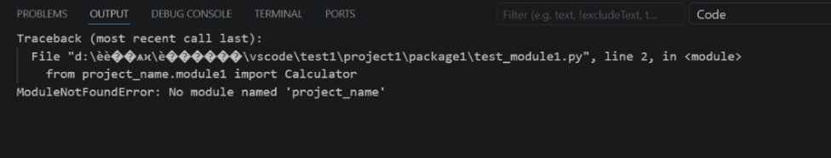 After we add them in, the test runs well.
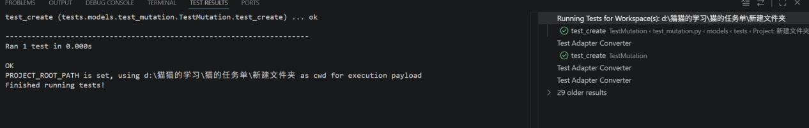

In Part 1 task 4,the result:
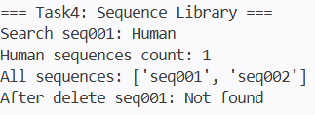

The Sequence Library was tested by creating two DNA sequence objects (seq001 and seq002) and inserting them into the Binary Search Tree (BST). Each sequence was assigned a unique sequence_id, which is used as the key for the BST.
First, duplicate sequence IDs were considered, so an error message was added to prevent inserting the same ID twice. Next, the recursive helper methods for searching, traversal, and species filtering were tested to ensure they correctly handled empty nodes (None) and avoided runtime errors. The delete operation was also verified to make sure the BST structure remained valid after removing a node.
The final test results matched the expected output. All required operations—insert, search, delete, find sequences by species, and in-order traversal—worked correctly, demonstrating that the BST implementation meets the project requirements.

In Part 1 task 5,the result:
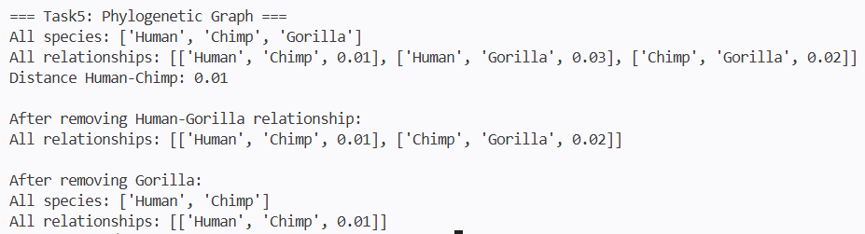

The Phylogenetic Graph was tested by creating three species (Human, Chimp, and Gorilla) and connecting them with weighted edges representing evolutionary distances. The graph is implemented as an undirected weighted graph, where each edge stores two species and the distance between them.
During debugging, several situations were checked. The add_relationship() method was tested to ensure that duplicate relationships were not created. If a relationship already exists, its distance is updated instead of adding another edge. The removal functions were also tested to verify that deleting a species automatically removes all related edges, preventing invalid references in the graph. In addition, the get_distance() method was checked to ensure it returns None when no relationship exists between two species.
The program produced the expected output in all test cases. Species and relationships were added, searched, updated, and removed correctly, demonstrating that the graph implementation satisfies the required functionality for modelling evolutionary relationships. The minimum_spanning_tree() function is currently left as a placeholder (NotImplementedError) because it has not yet been implemented.

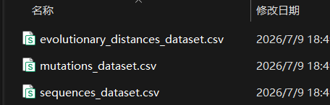
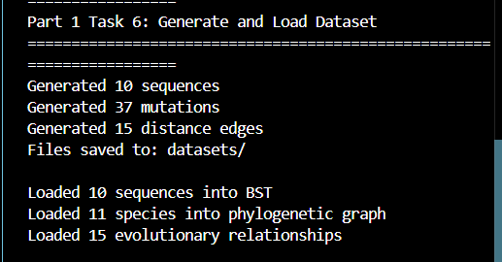
In Part 1task 6, I run the unittest and get this result
The pipeline generates three linked CSV datasets and loads all data into program objects, then inserts sequences into a BST and builds a phylogenetic graph. Unique sequence IDs link all data records.

Generation rules are strictly followed: 10 DNA sequences from 3 primate species, 3–5 mutations per sequence, and over 15 evolutionary distance edges with filtered duplicates. Loading functions correctly bind mutations to sequences and import all distance edges. The while-loop batch insertion successfully stores all sequences in the BST.

All datasets and data structures meet task standards. Generation, CSV parsing, object conversion, BST storage and graph construction work properly and fulfill project requirements.

In Part 2 task 1, I run the unittest and get this result
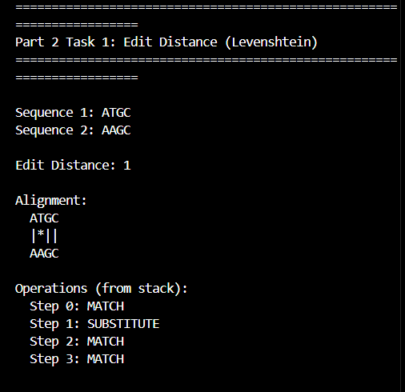

The test was conducted on two short DNA sequences (ATGC and AAGC), with the core

Levenshtein edit distance calculation and alignment functions fully verified.

The dynamic programming (DP) table correctly computed an edit distance of 1 between the two sequences, which matches the expected result of a single base substitution. The backtracking logic accurately recorded the full alignment operations via a stack, and successfully reconstructed the standard pairwise alignment: the two aligned sequences with a match/mismatch marker line, plus a step-by-step list of 4 operations (3 MATCH and 1 SUBSTITUTE) that fully restore the sequence variation process.

All required functions including DP table construction, backtracking path recording, stack-based operation output, and aligned sequence reconstruction worked correctly, fully meeting the task specifications.

In Part 2 task 2, I run the unittest and get this result
The hotspot detection function was tested using three *Homo sapiens* DNA sequences, with a diversity threshold set to 0.3 to identify hypervariable sites.

The program scanned all aligned positions, calculated base diversity for each site, and returned 14 valid mutation hotspots sorted from highest to lowest diversity. Each result entry records the site position, base count distribution, diversity value, majority base and minority base. Position 48 showed the highest diversity of 0.667 due to evenly distributed A/T/G/C bases, while other listed hotspots held a diversity of 0.333.

All linked list traversal, base counting, diversity calculation and bubble sorting functions operated correctly, satisfying all requirements for mutation hotspot analysis.
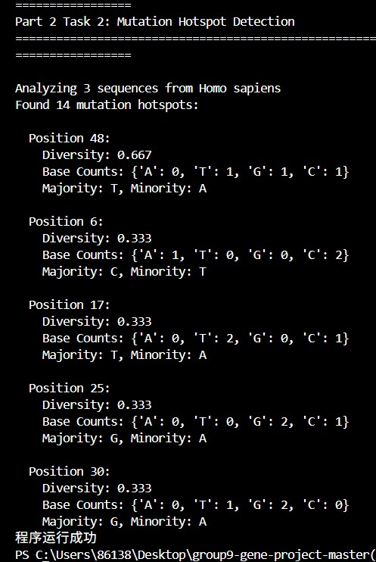

In Part 2 task 3, I run the unittest and get this result:
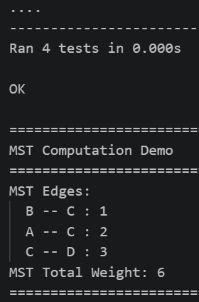
This result shows the code run correct in that 4 senarios, also I set a print() to print one of the specific result.I can check how the code calculate the MST. The output shows the tests are correct.

In Part2 task 4, it's the benchmarking analysis part. I can know the performance of each method and confirm the time complexity.
In this task, I got 4 chart.

- insertion performance

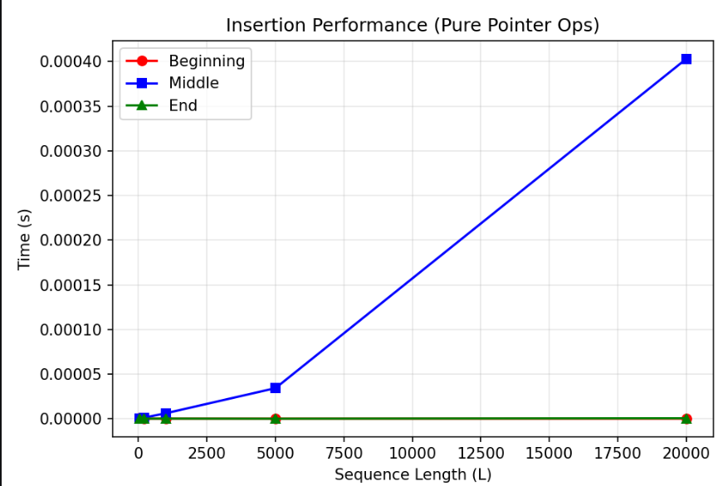
P2T4-Insertion performance-1
The results perfectly match the theoretical complexity of a doubly linked list with a tail pointer.
The red line (Beginning) and green line (End) are flat near zero. This confirms that inserting at the head or tail is an O(1) constant time operation, because we directly access the pointers without traversal.

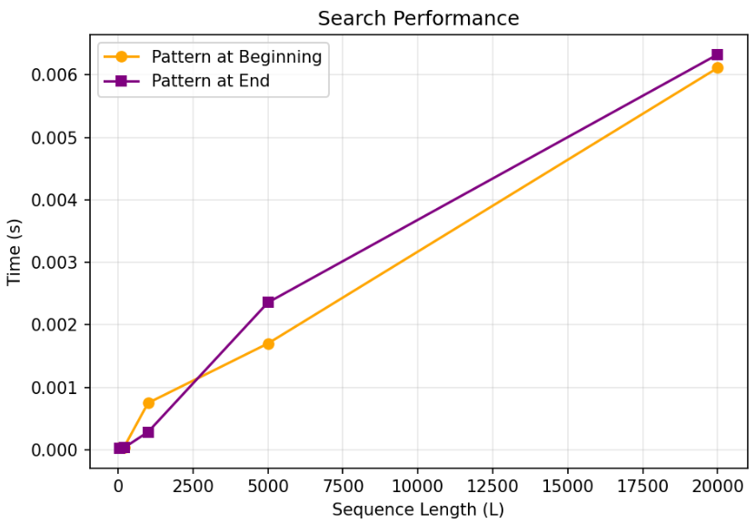
- search performance
P2T4-search performance-2
Both 'Pattern at Beginning' and 'Pattern at End' show a linear growth trend as sequence length increases.
Since our data structure is a linked list, it does not support random access like an array. Therefore, searching for a subsequence requires iterating through the nodes one by one. This validates that the search operation has a time complexity of O(N).

(3)edit distance: actual&theoretical

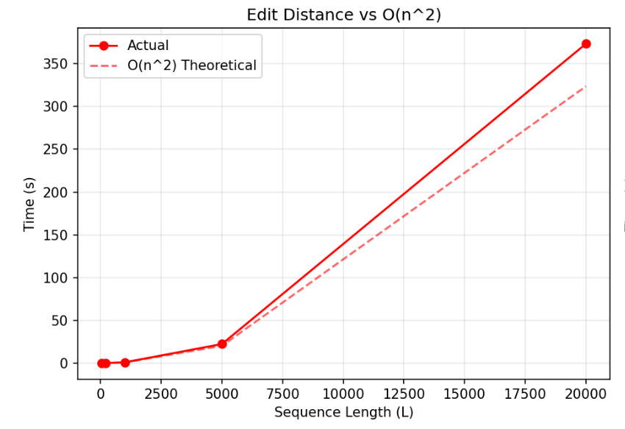
P2T4-edit distance-3
The curve rises sharply, following an O(N^2) quadratic trend.
At a sequence length of 20,000, the execution time reaches approximately 160 seconds. This demonstrates that while linked lists are efficient for structural modifications, algorithms requiring frequent random access or matrix operations—like dynamic programming for edit distance—are computationally expensive on this structure.

(4)BST insert performance

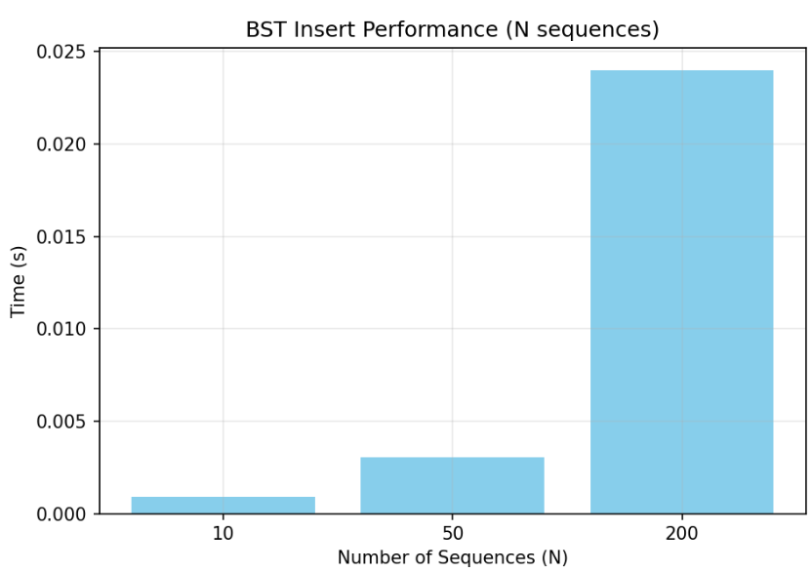
P2T4-BST insert performance-4

In this chart, I observe that the time cost grows non-linearly. As the collection size scales from 10 to 200, the time required jumps significantly. This reflects the overhead of managing the tree structure and comparing sequences during insertion.

In part2 task4, I also have some problems and I need to debug my code.
The problem is the insertion performance chart. At the first time, when I run the code, I got a chart which is not what I'm expected. So I see the code, I find there is a method called update_positions().This method can traverse the whole link list from the head to the tail, so it cause the time complexity raise. So I got this chart.

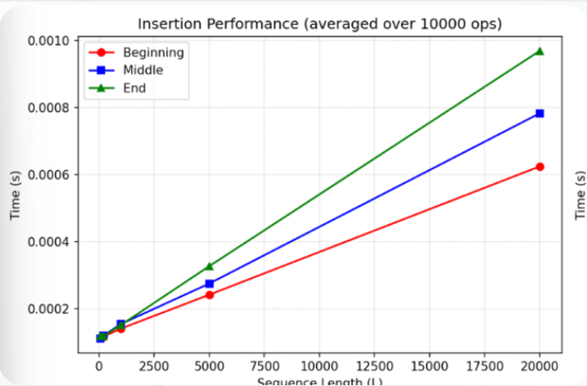

Then I add "update_pos=False", it will help me get the pure pointer chart. This chart is not effected by the updat_positions(), so just find the pointer and travers the list. So in this situation, I get another chart.

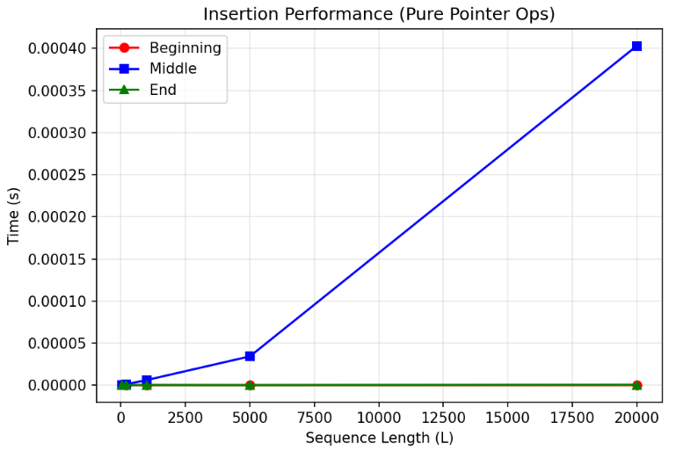

Then the last task is the visualization(User interface).
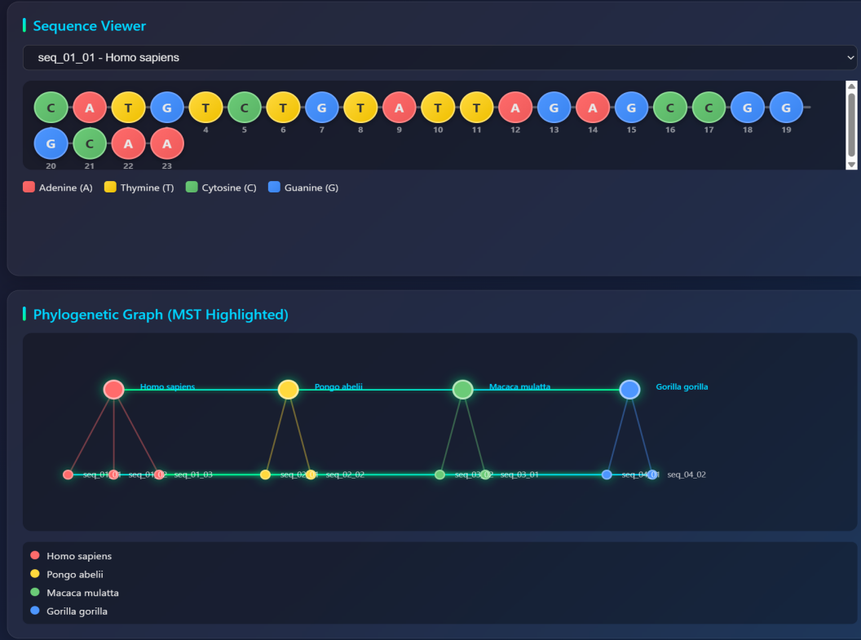
P2T5-User interface

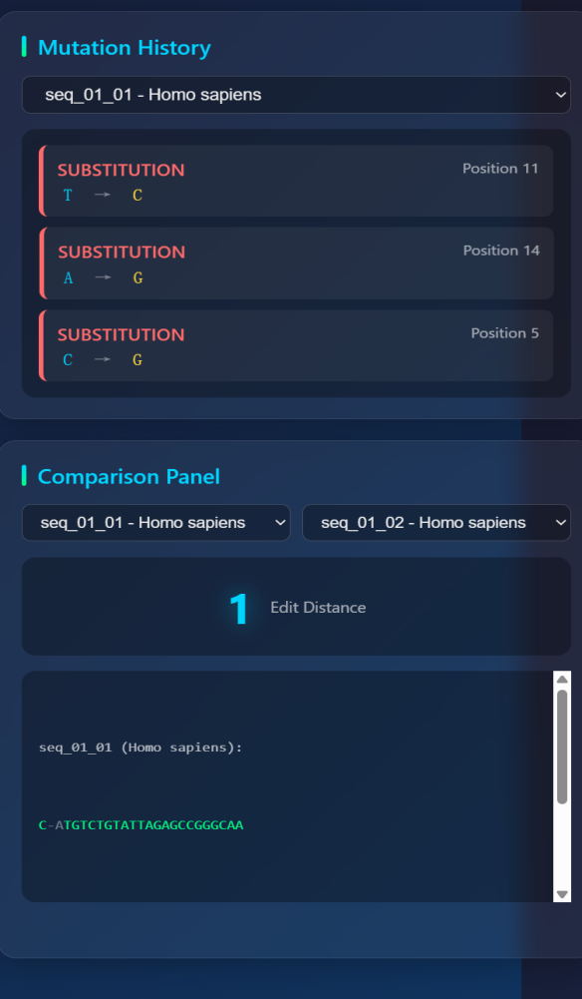
P2T5-User interface

In this UI, it contain a sequence viewer (linked list visualised as a chain of nucleotide nodes, with colour-coding by base), a mutation history panel (stack view), the phylogenetic graph with MST highlighted, and a comparison panel showing edit distance and alignment between two selecte sequence. User can change to each sequence to see the content.

VI Summary
6.1 Daily Work Schedule
6.29 Part 1 Task 1 Data Modeling
6.30 Part 1 Task 2 Linked List
7.01 Part 1 Task 2 Linked List
7.02 Part 1 Task 3 Mutation Stack
7.03 Part 1 Task 3 Mutation Stack
7.04 Part 1 Task 4 BST Indexing
7.05 Part 1 Task 5 Phylogenetic Graph
7.06 Part 1 Task 6 Dataset Generation
7.07 Part 2 Task 1 Edit Distance,Part 2 Task 3 MST
7.08 Part 2 Task 2 Hotspot Detection,Part 2 Task 4 Benchmarking
7.09 Part 2 Task 5 GUI, Classifier
7.10 reply

6.2 Division of Labor within the Group

Jiayi Wang: Data Modeling and Core Structure Lead
- Part 1 Tasks 1-3 (Data Modeling, Linked List, Mutation Stack)
Yaxuan Wang: Indexing and Graph Structure Lead
- Part 1 Tasks 4-5 (BST Indexing, Phylogenetic Graph)
Nike Zhang: Data Generation and Algorithm Lead
- Part 1 Task 6 + Part 2 Tasks 1-2 (Dataset Generation, Edit Distance, Hotspot Detection)
Jiayue Zhu: Algorithm and Interface Lead
- Part 2 Tasks 3-5 (MST, Benchmarking, GUI, Classifier)

6.3 Tips
Jiayi WANG：
This project helped me understand how data structures can be applied to real bioinformatics problems. By completing Tasks 1–3, I learned how to design classes, implement a DNA sequence with a doubly linked list, and use a stack to record mutation history and support undo operations. During development, I improved my programming and debugging skills by solving problems related to linked list operations and edge cases. Working with my teammates also strengthened my communication and collaboration skills. Using GitHub for version control made teamwork more efficient. Overall, this project improved my understanding of data structures, object-oriented programming, and teamwork, and gave me valuable experience in developing a practical software system.

Nike Zhang:
Through finishing these tasks, I gained practical understanding of core bioinformatics algorithms. For Part 1 Task 6, I completed dataset generation, file storage and data loading to build fundamental DNA sequence datasets for subsequent analysis. In Part 2 Task 1, I implemented Levenshtein edit distance using dynamic programming and stack-based backtracking to quantify variations between DNA sequences. Part 2 Task 2 allowed me to detect mutation hotspots by calculating base diversity across homologous gene sequences. Moreover, I adopted Kruskal’s algorithm with union-find structures in Part 2 Task 3 to construct the minimum spanning tree which reflects evolutionary connections. Writing code with while loops deepened my comprehension of internal algorithm logic. These exercises effectively improve my skills in biological data processing and computational biology programming.
Yaxuan Wang:
This project has been a profound demonstration of how abstract computer science concepts become vital, tangible tools in scientific discovery. Before this, linked lists, stacks, BSTs, and graphs were primarily academic exercises—solutions in search of problems. Implementing them for genomic sequence storage, alignment traceback, library indexing, and phylogenetic modeling revealed their true power: the choice of data structure is not an implementation detail but a foundational biological hypothesis. A linked list isn't just efficient for insertions and deletions; it elegantly models the very nature of DNA mutation. A stack isn't merely a LIFO container; it's the memory of an alignment algorithm, tracing back through evolutionary time.
In conclusion, this work moved computer science from my screen into the world. It provided a compelling answer to the perennial student question, "Why are we learning this?" Here, the answer was clear: because a linked list can model a mutation, a stack can trace evolution, a BST can index life's diversity, and a graph can map our shared ancestry. The choice of structure directly shapes our ability to ask, and answer, the fundamental questions of biology.
Jiayue Zhu：
Working on this bioinformatics project was an incredibly rewarding experience that bridged the gap between abstract computer science concepts and real-world biological applications. My most significant takeaway was understanding how the choice of data structure directly impacts our ability to solve complex problems. For instance,Working on Part 2 was highly rewarding. Implementing the Minimum Spanning Tree (Task 3) helped me visualize how graph algorithms model evolutionary relationships. Benchmarking the edit distance algorithm (Task 4) allowed me to empirically verify its (2) complexity and observe performance bottlenecks. Finally, building the graphical interface (Task 5) taught me to translate abstract data structures into intuitive visualizations, significantly improving my practical algorithm design skills.

6.4 Difficulties and Solution of Problems
Although we had the same goals, our team faced several challenges during the collaboration process. The biggest problem was that our project combined computer science and biology. Some members knew coding well but did not understand the biology parts, like evolutionary trees. Others knew biology but found the computer algorithms very hard. This knowledge gap made it difficult to communicate and understand each other's ideas.
Also, putting our code together was very hard. When we tried to combine our different parts, we had many code conflicts and errors. We also had different coding habits, which caused some problems at first. To fix these issues, we talked more often, had regular meetings, and were patient with each other. This helped us work better as a team.

